Social Studies 20-1
- Ultranationalism and Crimes Against Humanity
- National Self-Determination
ASSIGNMENT BOOKLET 2B

SENIOR HIGH SCHOOL
Fort Saskatchewan 780 992 0101
Sherwood Park 780 464 1899
Vegreville 780 632 7998

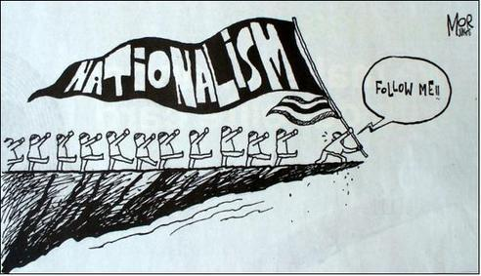

Assignment Booklet Questions Rubric 10-1/20-1/30-1

 | Excellent (5) | Proficient (4) | Satisfactory (3) | Limited (2) | Poor (1)
Communication:  Consider effectiveness of student’s:  - organization  - Syntax, mechanics, and grammar  - Use of vocabulary and Social Studies terminology | Writing is fluent and skillfully structured. Controlling idea effectively sustained and integrated. Skillfully control. Absence of error impressive. Precise, deliberate vocabulary. | Writing is clear and purposefully structured. Controlling idea coherently sustained and integrated. Capable control. Minor errors do not impede communication. Appropriate, specific vocabulary. | Writing is straightforward and functionally ordered. Controlling idea generally maintained. Basic control. Occasional lapses and minor errors, however generally clear. Conventional, adequate vocabulary. | Writing is awkward and lacks clarity. Controlling idea inconsistently maintained. Faltering control. Errors obscure the clarity of communication. Imprecise, simplistic vocabulary. | Writing is unclear and disorganized. Controlling idea is absent. Lack of control. Jarring errors impede communication. Overgeneralized, inaccurate vocabulary.
Interpretation & Analysis of Responses:  Consider how effectively the students:  - Critically analyze and demonstrate an understanding of the question | Insightful and sophisticated analysis and understanding of question. Perceptive, and comprehensively developed response. | Sound and adept analysis and understanding of question. Purposeful and capably developed response. | Straightforward and conventional analysis and understanding of question. Generalized and adequately developed response. | Analysis and understanding of question incomplete, lacks depth. Response is superficial and lacks development. | Minimal analysis and understanding of the question. Disjointed and vague response.
**IMPORTANT: Students are expected to complete ALL OF THE QUESTIONS in the assignment booklets. Booklets with less than 85% complete will be returned to the student for completion. **

Chapter 7: Ultranationalism and Crimes against Humanity
____________________________________________________

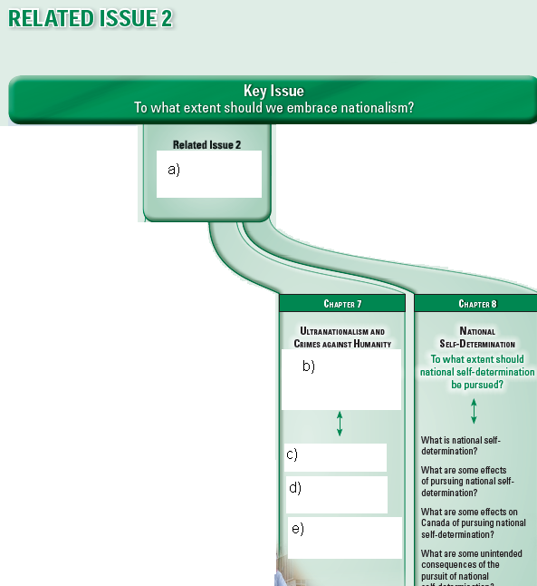
________________________________________________________________

a.
b.
c.
d.
e.

2. (Page 158-159) Chapter Issue: To what extent can the pursuit of
Ultranationalism lead to crimes against humanity?

a) Explain what ultranationalism is:

b) What are crimes against humanity? Give a definition, and give one

example.

c) (Page 158) Figure 7-1

What do you feel when you look at the photograph of the destruction of Hiroshima?

What might be written on the lanterns that are floating on the river?

3. (Page 159 continued)

a) In May __________________, Germany surrendered and the _______

World War was over in Europe. But Japanese troops were still fighting in the

______________________ though they had been _______________________.

b) What were American leaders preparing to do in 1945?

c) What did many Americans believe about the Japanese commanders?

d) When and where were atomic bombs dropped?

Date: | Place:

e) Do you think dropping the atomic bombs was an appropriate response to Japanese ultranationalism? Give reasons for your response.

4. (Page 159) Key Terms

Define the following Key Terms.

genocide:

war crimes:

Holocaust:

ethnic cleansing:

6. (Page 161-163) What are crimes against humanity?

Complete the following cause and effect chart.

Cause | Effect
People’s dedication to their nation can
 | instill feelings of pride.
Passionate nationalism and strong leaders

Japanese soldiers invaded Nanjing

7. (Not in textbook)

Consult an atlas or an online map of China, then draw and label the Chang Jiang River. Place a dot on the map to plot Nanjing, and label the city. Draw Japan onto the map.
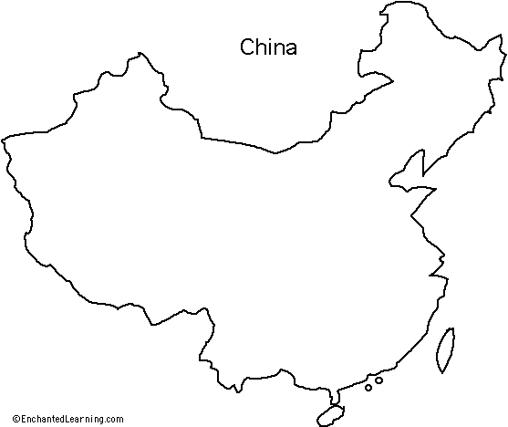

In point form, list some things that Hong Guiying remembers about the massacre in 1937.

8. (Page 160) What are crimes against humanity?

a) J. Robert Oppenheimer was the director of ___________________________

________________________________________________________________

b) United States dropped _____________of these ______________ on

_________________________ in the year ____________________.

c) Up to ___________________________ people died.

d) In later years, ___________________ from the ________________

continued to _________________________, and __________________ more

died from ________________________ and _____________________.

9. Go through the following notes:
Crimes Against Humanity Notes
Download File

10. (Page 161) Naming the Crimes

a) Explain what each of the three types of war crimes are.

b) What is the ICC and what is its role?

c) (Page 162) Voices

Consider Dozier’s opinion about hate. What do you think Dozier means by the word “dehumanize”?

________________________________________________________________

________________________________________________________________

________________________________________________________________
________________________________________________________________

________________________________________________________________

11. (Page 162) Ultranationalism and Crimes against Humanity

a) Just as

can lead to ,

ultranationalism can lead to .

b) Ultranationalism seems to develop in stages.

Stage 1. Ultranationalism may start by

Stage 2. Then the movements of victims are

Stage 3. They may be pushed to

Stage 4. Their culture is often

Stage 5. They may be

Stage 6. and even

c) Consult a dictionary, and define the following words.

bigot:

segregate:

12. (Page 162 continued)

a) What happened to Hrant Dink and why?

b) Explain what is meant by a “state-sponsored act” and give an example to support your explanation.

c) What is meant by the following statement:

“These murderers believe that these acts promote their national interest.”

14. (Page 163) How Has Ultranationalism Caused Crimes Against Humanity?

a) In the past, what has caused people to commit crimes against humanity,
genocide and war crimes?

b) People around the world study these crimes to:

c) Consider for a moment the impact of peer pressure in your life—both what you have seen, and personally experienced. In the chart below, give examples of positive peer pressure, and negative peer pressure that you have seen in your own life.

Positive Peer Pressure | Negative Peer Pressure

d) To what extent do you think peer pressure is a factor motivating ordinary people to commit crimes against humanity, genocide, or war crimes? Make an X on the spectrum below, and explain your reasons.

________________________________________________________________

small extent large extent

Reasons:

15. (Page 163-164) Genocide in Turkey—1915

The central conflict in Turkey 1915:

versus

Fill in the timeline of issues and events:
late 1800s

during WW I

1914

April 24, 1915

1919

1931

16. ( Page 165) Famine in Ukraine – 1932-1933

_____ What is the nature of the original conflict in the Ukraine?

a. The Russian Revolution left many Ukrainian persons homeless
b. Bolsheviks needed the Ukrainian-grown wheat for the growing army
c. Stalin acknowledged the famine and seized Ukrainian wheat
d. Ukrainian nationalists tried to declare independence

_____ Ukraine was known as the:

a. breadbasket of Europe
b. ultranationalist zone of resistance
c. Prosperous Land of the Kulaks
d. region disloyal to the Russian cause

_____ The Kulaks were:

a. supportive of Joseph Stalin’s five-year plans
b. poor farmers trying to survive on subsistence crops
c. collectivists who believed in Marxism
d. resistant to the concept of collective farms

_____ Stalin took control of the Soviet Union with the goal to:

a. offer Ukraine an increase in prices for grain
b. carry out his plans to modernize the country
c. support the breadbasket of Europe
d. store grain for future use in times of famine

_____ The Soviet troops seized grain in order to:

a. redistribute it to those in the greatest need
b. use it for bread to feed his rapidly growing army
c. sell the grain on world markets for profit
d. recognize the necessity of Holodomor

_____ Western nations responded to Stalin by:

a. praising his drive to modernize Soviet Union
b. protesting to his brutal treatment of the Kulaks
c. writing news reports that exposed genocide
d. giving Stalin extensive loans to support collectivization

a) (Page 165) What is the translation of Holodomor?

________________________________________________________________

c) What do both Perehinec and Panasiuk want?

d) Why do you think it took so long to give formal recognition to the genocide?

18. (Page 165) Figure 7-8

a) Discuss the meanings of three different symbols that were captured in the
photograph.

b) Why would it be important to build a memorial like the one in the photograph to
honor those who died in the famine? Does a memorial make a difference?



19. (not in textbook)

Use the following quotation to answer the question that follows.

“Those who cannot remember the past are condemned to repeat it.”

---George Santayana, The Life of Reason, Volume 1 (1905)

In two paragraphs, discuss whether or not you agree with this quote. Relate your answer to the Holodomor in Ukraine.

20. (Pages 166-167) Shoah—The Holocaust

a) How did Josef Pitel manage to survive the Holocaust?

________________________________________________________________

________________________________________________________________

21. (Pages 166-167) Shoah—The Holocaust

WATCH: I Survived The Holocaust Twin Experiments

a) What was Adolf Hitler’s ultranational dream?

c) What are six other people groups besides the Jew who were persecuted and killed during World War II?

22. (Page 166) International Response to the Threat

Highlight the True statements.

_____ During the 1930s, the rest of the world largely ignored what was happening in Germany

_____ Many countries had their own financial problems to deal with

_____ The Canadian government had discriminatory attitudes towards the Jews

_____ The ship The St. Louis was welcomed in Canada

_____ China and Denmark persecuted and killed Jews

23. (Page 166-167) Growing Awareness

Explain the problem that Gerhart Reigner had. Could his problem be repeated today?

In April 1945, Allied forces liberated the Nazi death camps. What did the liberators find there?

24. (Page 167) Why Remembering Matters

Choose two short portions of Elie Wiesel’s speech that you particularly liked, quote them in the space below, and comment on why you like what he said.

(1)

(2)

25. (Page 167) Explorations

a) Should the many governments and individuals who did nothing to stop the persecution of Jews and others in Germany be considered guilty of crimes against humanity? Explain your response.

b) The guards at the Nazi death camps, the contractors who built the death chambers, the clerks who registered the numbers tattooed on every Jew, and many more people involved in Adolf Hitler’s extermination program were all ordinary citizens with spouses, children, mothers, fathers, boyfriends, girlfriends, and neighbours.

With this in mind, explain whether you think similar crimes against humanity could happen in Canada. Provide reasons for your judgment.

26. (Page 168) The Bombing of Hiroshima and Nagasaki—1945

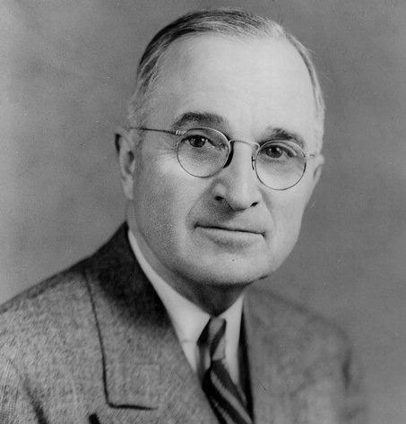
What is the central dispute that was argued between General Dwight D. Eisenhower and President Harry S. Truman? Write their opposing beliefs.
President Harry S. Truman

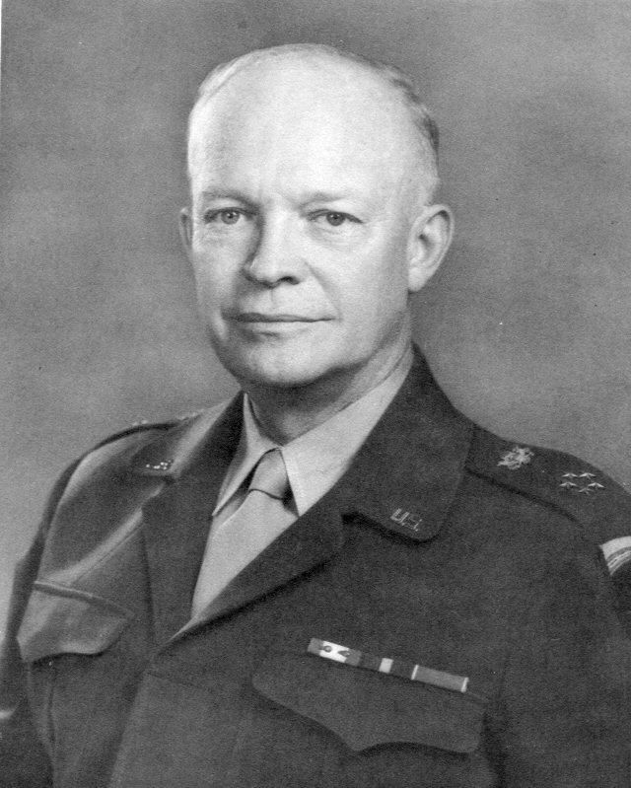

General Dwight D. Eisenhower

Were the bombings of Hiroshima and Nagasaki acts justified by war, or were they criminal acts? Explain your response

27. (Page 169) The View from Here
Summarize the points of view of the following individuals. The issue is whether or not dropping the atomic bomb on Hiroshima was in the national interest of United States, or was it in the interest of all humanity?

Leo Szilard believes that:

Mitsuo Okamoto believes that:

Oliver Kamm believes that:

Whose point of view do you agree with the most? Explain what exactly you agree with, and why.

28. (Pages 170) What are some contemporary consequences of
ultranationalism? and Bringing Criminals to Justice and The International Criminal Court

a) Since the end of World War II, many countries have tried to find ways to _____________________ the extreme forms of ________________ that lead to _____________________ and ________________.
b) The League of Nations _________________ to prevent the horrors of ________________________.
c) It was believed that a ____________________where conflicts could be resolved peacefully was in every nation’s interest—and the ____________________________ emerged from these discussions.
d) In 1945, the UN had no ______________________________ to try war criminals.
e) In 1948, the UN established a committee to

f) What happened in 2002?

g) By 2008, there were ____________ more countries who also signed on.

29. (Page 171-172) Serbian Ultranationalists and the Siege of Sarajevo

a) What does ethnic cleansing mean?

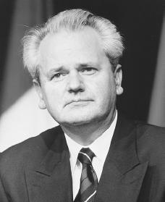

What was the outcome of Slobodan Milosevic’s trial?

30. (Page 173) Crimes against Humanity in Rwanda

WATCH: How could the Rwandan genocide happen? - BBC Africa

a) The central conflict in Rwanda appears to be:

Versus

b) Fill in the issues and events in the arrows of the timeline:

1962

1993

April 1994

c) Who is Romeo Dallaire, and what had he been trying to do?

d) What was the estimated number of deaths in this genocide?

e) What percentage of those who had been murdered were Tutsis?

f) What was Dallaire’s request, and why was it rejected?

g) What is the fundamental question that the genocide in Rwanda raised?

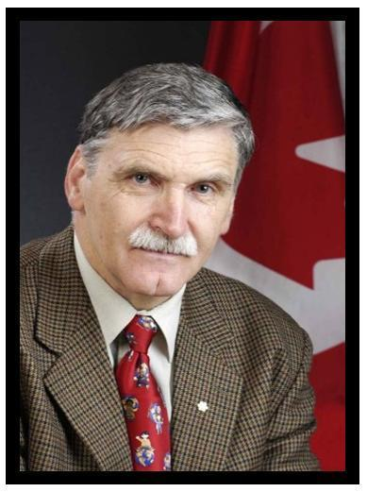
Romeo Dallaire
Image Accessioned from: http://www.pugwashpeaceexchange.org/aboutus.aspx (Sept 19, 2009)

31. (Pages 176-177) Acting for Good in the Face of Evil
Choose ONE of the persons featured—Oskar Schindler, Feng Shan Ho, or
Paul Rusesabagina—and explain how they tried to protect victims of crimes against humanity and genocide.

Now from the same three persons, choose one whom you would try to be the most similar to in actions if you had the opportunity to protect victims of crimes. In one or two paragraphs, explain what you could do, just as that person did, or alternatively, explain why you feel you could not copy their good example.

Social Studies 20-1
Chapter 8: National Self-Determination
________________________________________________

32. (Page 181) Chapter Issue

- What is the Chapter Issue for chapter 8?

- Using the glossary, define the following terms:

self-determination

decolonization

successor state_

c) Canadians have many _____________for expressing opinions about what is

in their ________________ interests.

d) Canadians can vote for representatives on ____________________ councils,

___________________ or ______________________ legislatures, and in

_______________________..

e) Canadians can also take their concerns directly to

f) Which First Peoples groups tried to resolve their land-claim dispute with the
Quebec government?

g) Demonstrators in _____________ were arrested for speaking in favor of

self-determination.

33. (Page 180) Figure 8-1

- What do the people paddling the boat hope to achieve?

b) Look carefully at these three images. What is the relationship between the three images, and what is ironic about how these images are grouped together?

34. (Pages 182) What is national self-determination?

a) The word “determined” we may often think of as meaning that somebody is very dedicated to getting something they want or need. We all want the freedom to decide or “determine” our own futures, our own destinies.

What are some things in your life that you would like to determine for yourself, without other people just telling you what to do?

b) When a people group pursues national determination, what are they trying to get, and what do they believe?

c) (Page 182 continued)

.Fill in the timeline that Kosovo progressed through over time.

At one time:

then

then

35. (Page 183) Self-Determination and Nation-States

a) What two ideas about self-determination did Louis L. Snyder acknowledge that are completely opposite in their effects upon people?

b) On the nation-state level, self-determination helps people see their

nation as “_____________________________________” but on a group or

collective level, the pursuit of self-determination can _________________ a

nation-state if some people do not _____________________ that the state

represents their ___________________ or supports _____________________.

c) Explain the position that the United Nations takes in its charter towards a nation’s right to self-determination.

d) (Page 183 continued)

What issue did the United Nations face in Kosovo? Explain how the issue evolved, and what the end solution was

36. (Page 184) What are some effects of pursuing national self-determination?

a) What is the pursuit of national self-determination often complicated by?

b) What are three required parts that describe what “a people” group is?

c) (Page 184) Decolonization and Self-Determination

Colonies are

In 1914, Canada was

d) Decolonization refers to what happens when

The people of a former colony may then form

e) Decolonized countries can _______________________ and exercise

__________________________under ______________________________.

f) decolonized peoples must often deal with the

Colonial powers often __________________ peoples who were once separate

into a single ______________________.

38. (Page 187 and 189) Tibet and the Pursuit of National Self-Determination

a) Read both pages. Describe what the central issue is in Tibet.

b) How has the United Nations responded to the issue?

c). Why would the Tibetans worry about assimilation?

________________________________________________________________
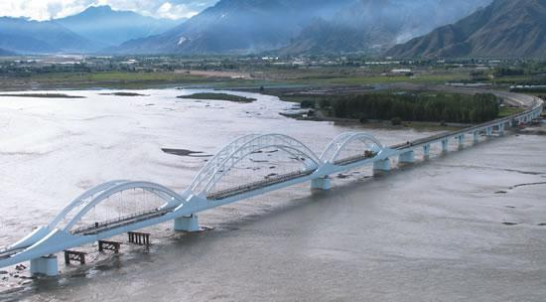

Qinghai-Tibet Railway

Photograph accessioned from: http://www.chinapage.com/road/qinghai-tibet-railroad/photo/photo.html (June 1, 2009)

39. (Page 189) Focus on Skills

a) Read the three sources on page 189.

In Source 1, what is the main point the author is trying to prove?

What method or strategy does the author use to prove their point?

b) In Source 2, what are five strong words or phrases that the Dalai Lama uses to intensify his news release?

Explain whether you agree or disagree with the point the Dalai Lama is trying to make.

c) In Source 3, what does the Chinese embassy’s news release try to emphasize?

From Source 3, choose a sentence or phrase, write it below and use quotation marks around it. Provide several comments as to whether or not you agree with the perspective of the statement.

40. (Pages 190) Successor States

a) Explain what is a successor state and give an example of how a successor state is formed.

b) What is a “predecessor state” and what rights does a “predecessor state” have according to the United Nations charter and international law?

41. (Page 191) India as a Successor State

WATCH: National Interest - Self-determination

a) Britain controlled what are today the ______________________ nation-states

of _________________________, __________________________,

___________________________, and _________________________ .

b) How are the Hudson’s Bay Company and the East India Company similar?

c) What happened in 1858?

Why was the Raj a difficult era?

42. From pages 190-191, create a timeline that includes the following years:

Early 1800s, 1858, Late 1800s, 1906, 1919, 1920s, 1930s and 1940s, early 1940, 1944, August 15th 1947, August 17th 1947

In your timeline, include the dates, and short explanations of the events.

43. (Page 191) Non-Violent Protest

What were Mohandas Gandhi’s beliefs about how to foster Indian nationalism? Explain his beliefs, and explain whether or not you agree with his beliefs, and why.

44. (Page 191) The Creation of Pakistan

a) What was the goal of the Indian National Congress, and why was this organization’s goal so difficult to achieve?

b) What was the result of the rift experienced by the Congress Party?

45. (Page 190) Figure 8-10, Map of India, Pakistan, and Kashmir

Look carefully at the map, and use the information on page 191 to explain why the creation of Pakistan and Bangladesh caused violent conflicts.

46. (Page 191) The Creation of Pakistan

a) What do Muhammad Ali Jinnah and Mohandas Gandhi say to each other in their letters?
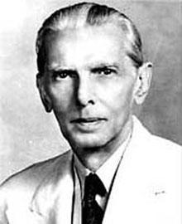

Muhammad Ali Jinnah
(Image accessioned on July 2, 2009 from:
http://www.nndb.com/people/263/000088996/jinnah-1.jpg)

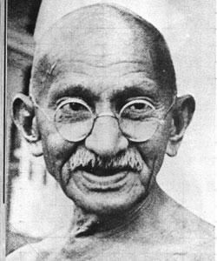
Mohandas Gandhi
Image accessioned from: http://jasonwisdom.com/wp- content/uploads/2008/07/ mohandas_gandhi.jpg (July 2, 2009)

b) With whom do you agree with more—Jinnah or Gandhi? Explain why.

47. (Page 192) Kashmir

a) Explain what the issue in Kashmir is:

b) What did the United Nations decide in 1948?

c) What action was taken regarding United Nations’ recommendations?

d) According to the map on page 190, what seems to have been decided regarding Kashmir?

(Page 192 continued) There is an ongoing concern, however:

e) “The part of Kashmir controlled by ____________________ includes more

than ________________ as many Kashimiris as the section controlled by

________________________.

f) Though the original plebiscite was to

many nationalist leaders in Kashmir are now calling for

48. (Page 193) What are some effects on Canada of pursuing national
self- determination?

WATCH: National Interest - Aboriginal Self-determination

Complete the following sequence of events.

early 1600s

first colonized by

then

Aboriginal Peoples became

Aboriginal people’s territory was

and their right to self-determination

49. (Page 193) What are some effects on Canada of pursuing national
self-determination?

Use the following excerpt from the textbook to answer the question that follows.

In Canada today, as in many other countries, two of the UN’s core values offer conflicting views on self-determination. On one hand, UN member countries have the right to sovereignty; on the other hand, the peoples within those countries have the right to control their own affairs and make decisions in their collective interests.
(Exploring Nationalism Page 193)

In your opinion, which is more important: a nation’s sovereignty, or supporting the various people groups within a nation in their efforts to control their own affairs? Give reasons and/or examples to support your opinion.

50. (Page 193) First Nations’ Pursuit of Self-Determination

a) According to the Assembly of First Nations (AFN), self-determination involves the right of a people to freely:

b) How does the AFN statement compare or contrast to the United Nations recommendations?

c) Many people mistakenly think that the First Nations‘ pursuit of
self-determination means that First Nations want to break away from Canada and form their own country. What does the 1996 report People to People, Nation to Nation do to clarify this misconception, and what does it conclude?

d) How does the new Canadian law that was passed in 2005 help support First Nations’ pursuit of self-determination?

e) (Page 193) Voices

Marlene Buffalo has her own point of view of the issues she sees, but her words may also represent the perspective of the entire Samson Cree Nation.

Complete the mini-chart below that summarizes Marlene’s statement, and serves as a starting point for setting goals.

Identifiable Problems:

Problems were caused by:

Long-Term Solution:

If you were helping Marlene try to set up some short-term goals to try to reach her long-term solution, what are three things you would help her to do?

Three Short-Term  Goals | 1)  2)  3)

51. (Page 195) Education and Renewal

Just as many schools offer special courses for students to learn language and culture—such as French, Chinese, Ukrainian, and German—some First Nations have established schools where young people can be educated in their own language according to traditional values and knowledge.

Explain how Amiskwaciy Academy and the First Nations University of Canada help to renew cultural pride and promote self-determination for the First Nations peoples.

52. (Page 195) Inuit Pursuit of Self-Determination

a) Nunavut has self-determination and self-government. Read the section, then explain two key differences that have been made to reflect the Inuit way of governing and promoting their culture.

b) (Page 195) Inuit Tapiriit Kanatami

What is the Inuit Tapiriit Kanatami, and what are some activities that it does?

53. (Page 196) Métis Pursuit of Self-Determination and Figure 8-15

a) Read the five paragraphs on page 196. The Canadian Constitution recognizes Métis as one of three Aboriginal peoples who possess Aboriginal and treaty rights. Though the Métis do not have Reservations like the treaty First Nations do, the Métis do have settlements.

In point form, list ten fast facts that summarize what you have learned from the written text and the map.

END OF MODULE 2B. SUBMIT YOUR MODULE TO BRIGHT SPACE AND COMPLETE THE QUIZ & ESSAY FOR UNIT 2

